Luke Leiter

CMPSC 475

Project Proposal

10-25-2021

**Home Quartermaster**

Sometimes keeping track of all our stuff can be time consuming and stressful. Especially when we must remember what need upkeep and when. For example, my dad has often forgotten if he owns a tool and where it would be. Sometimes he might by a second tool he already owns and not even no it! Another example to demonstrate my problem is my car. While I don’t loose my car it does need maintenance done. Between my wife’s car and my car I don’t always remember which is taken care of. Last year I forgot to renew my registration and got a ticket as a result. My app would help keep track of things the user owns. It will allow the user to add reminders and dates to an item so the user can keep track of important maintenance. Current ways to solve this problem are with reminders in a to-do app or a calendar. But that can be clunky and doesn’t have a great way to help keep track of numerous items. There are apps that allow the user to save lists of items they own and even in what room, but this is focused on the organization aspect. Airbnb owners also use these apps to keep track of different properties they own and what is in them. The app will essential be nested lists; it will allow the user to create items and group the items however they wish. The user will be able to add information about the item and different tasks associated with the item. These tasks could have reminders associated with them, such as a date to get your car inspected. The data will be created and accessed by the user through various activities and fragments. The name comes from a position I held when I was in Boy Scouts. The Quartermaster of the troop kept record of the troops gear and what maintenance needed done. This app is a Quartermaster for the home, the Home Quartermaster.

This is an Entity Relation Diagram. These are the entities the data will be stored in and how they will relate to each other.

The user will create this data through a from the app provides to them. The names and description of entities will be text boxes and other data will be auto generated or drop-down choices.

These are all the fragments to user will interact with. The plus button will add a new Item Group or Item depending on the current fragment. The arrows on the items will allow the user to see a summary of the item. Clicking on the item will allow the user to see more details on the items in addition to allowing them to create more actions for an item.

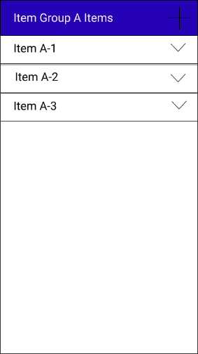

The user will have an account that links his data to him, the data will have the option of being stored in the cloud or locally. The list of Item Groups, Items in a group, and the Item itself are all different fragments of the same activity. The recycler view can be used when the user has too many item groups or items to be displayed on one screen. There will eventually be an option to bring up a menu to manage the user’s account. The data will be stored in a database which will be accessed with Room. I will be posting the app on the app store and will allow the user to use his google account. I would also like to play with the accelerometers to use the phone shaking as an action. This is how Home Quartermaster will fulfill the project requirements.